We want to install putty, an ssh client on the laptops. In the web browser goto:
www.chiark.greenend.org.uk/~sgtatham/putty/download.html

Under “Alternative binary files grab 32 bit putty.exe and put it on the desktop
Click on the putty icon to run the application. It should bring up:

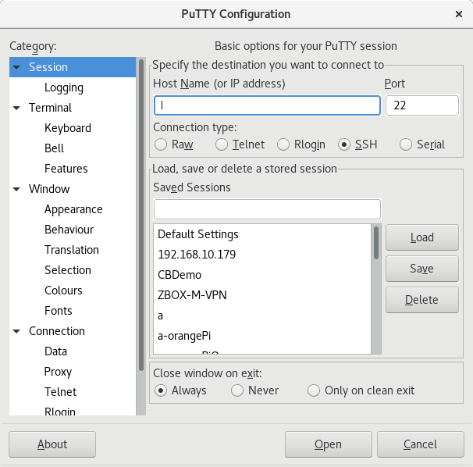

The instructor will have given you a hostname something like:

vmX-duval.eastus.cloudapp.azure.com

Where the X will be replaced with a number. Put this name in the Hostname field. Use the value of to the first ‘.’ in the “Saved Sessions” field, so you should now have something like this:

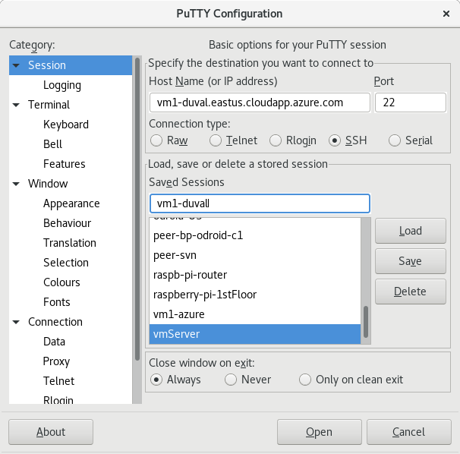
Hit the Save button to save this. Then scroll the Category window down so you can see SSH and expand that window option, then select Tunnel so you get this screen:

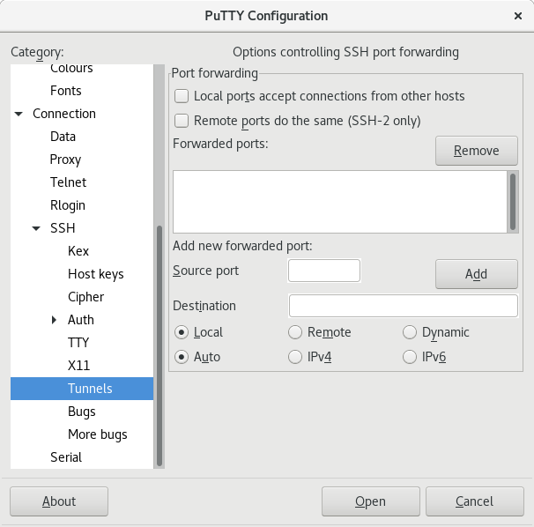

We want to set it up to tunnel local connections to port 80 and 433 through the SSH connection to the azure based web server you are about to set up. Use Source port and Destiation fields you enter
Source port: 80 Destination 127.0.0.1:80 hit add
Source port 443 Destination 127.0.0.1:443 hit add

You should now have:
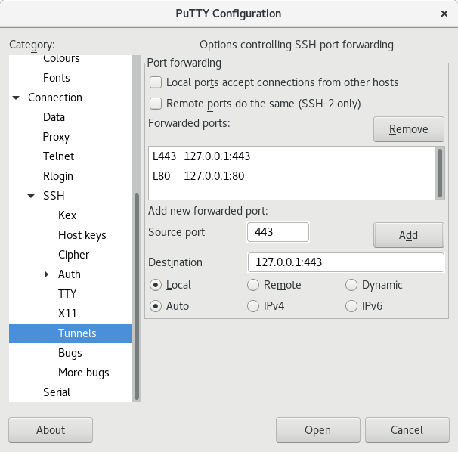
Scroll Category window back to the top and highlight Session:
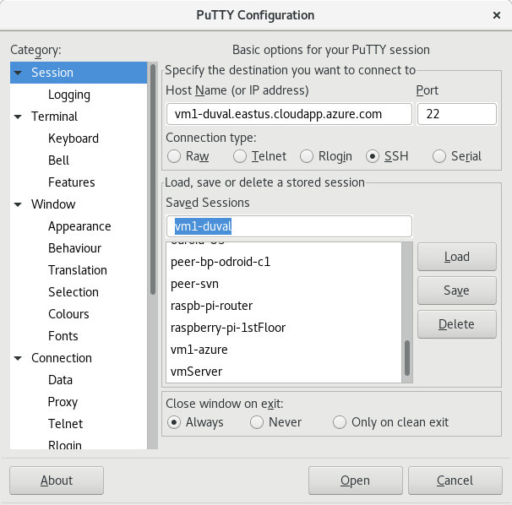
Hit the “Save” button again and then hit the “Open” button to connect to your Azure VM. You should get “Putty Security Alert”, hit the “Accept” button and you should get the login prompt.
Login as: duval
You will be told what the password is.

You shold be connected to the command line.

Become superuser and install any updates:

sudo bash
apt-get update
apt-get upgrade

See what ports are currently listening to ports: netstat -lntp

Hopefully it’s only listening on port 22.

Lets install our web server: apt-get install apache2 apache2-utils

Now what ports are listening: netstat -lntp

Lets go ahead and enable https:

a2enmod ssl
a2ensite default-ssl
systemctl restart apache2.service

What ports are listening now?: netstat -lntp

We should have 22, 80 and 443. If you don’t have these three ports ask for help.

You can verify the web server is working by web surfing to
http://localhost/
and
https://localhost/
You’ll need to add an exception at this point get to the site, Select the “Advance” button, then select the “Add Exception...” button, finally select “Confirm Security Exception” to get to the default Apach2 web page.

Wordpress uses the mysql server database so lets install it: apt-get install mysql-client mysql-server

You’ll be asked if you want to set a password for the mysql root user, set it to the password you used to login to your VM.

Port 3306 should now also be on the list: netstat -lntp

Notice that the mysql server is only listening on localhost (127.0.0.1)

We want to secure the mysql install: mysql_secure_installation

You will be asked to Enter password for user root, which is the one you set on the install of the mysql server.

You will be asked “Would you like to setup VALIDATE PASSWORD plugin?”,
the right thing to do would be to enter Y but for now we don’t want to enable this so respond: n

You be asked:Change the password for root ? ((Press y|Y for Yes, any other key for No)
Respond: n
You’ll be asked “Remove anonymous users? (Press y|Y for Yes, any other key for No)”,
Respond : y

You’ll be asked “Disallow root login remotely? (Press y|Y for Yes, any other key for No)”
Respond: y

You’ll be asked “Remove test database and access to it? (Press y|Y for Yes, any other key for No) “
Respond: y

You’ll be asked “Reload privilege tables now? (Press y|Y for Yes, any other key for No)”
Respond : y

Wordpress utilize the PHP program language so install it:
apt-get install php php-mysql libapache2-mod-php php-cli php-gd

Restart the web server: systemctl restart apache2.service

Set up a file that we can use to verify PHP is installed correctly
nano /var/www/html/info.php
And paste the code below into the file, save it and exit.
<?php
phpinfo();
?>
Use
Make sure PHP is working by Websurf to: http://localhost/info.php
This should show PHP home page

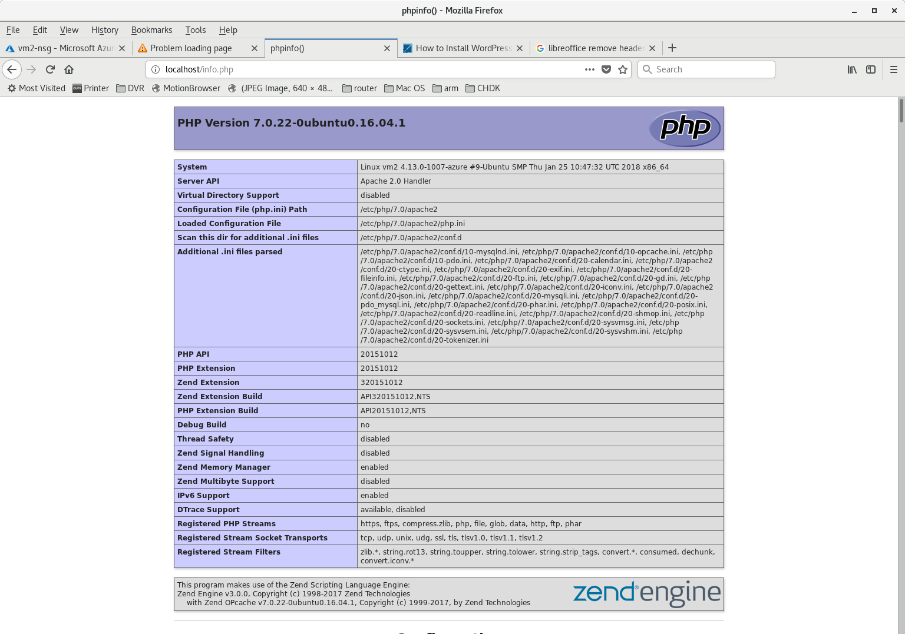
We want to remove the default apache screen so it’s not a problem later: rm /var/www/html/index.html

Now we want to install installation for Wordpress. Enter the following commands:

wget -c http://wordpress.org/latest.tar.gz
tar -xzvf latest.tar.gz
rsync -av wordpress/* /var/www/html/
chown -R www-data:www-data /var/www/html/
chmod -R 755 /var/www/html/

We need to creat the word press database: mysql -u root -p
You’ll be asked for the root password you set for mysql, enter it and you should get the mysql prompt “mysql>”. At this prompt enter the following commands:

CREATE DATABASE wp_myblog;
GRANT ALL PRIVILEGES ON wp_myblog.* TO 'duval'@'localhost' IDENTIFIED BY 'myblogdbpassword';
FLUSH PRIVILEGES;
exit;

At this point we should be able to use the web browser to finalize the wordpress install. Web surf to : https://localhost/wp-admin

Your should get a screen like this:

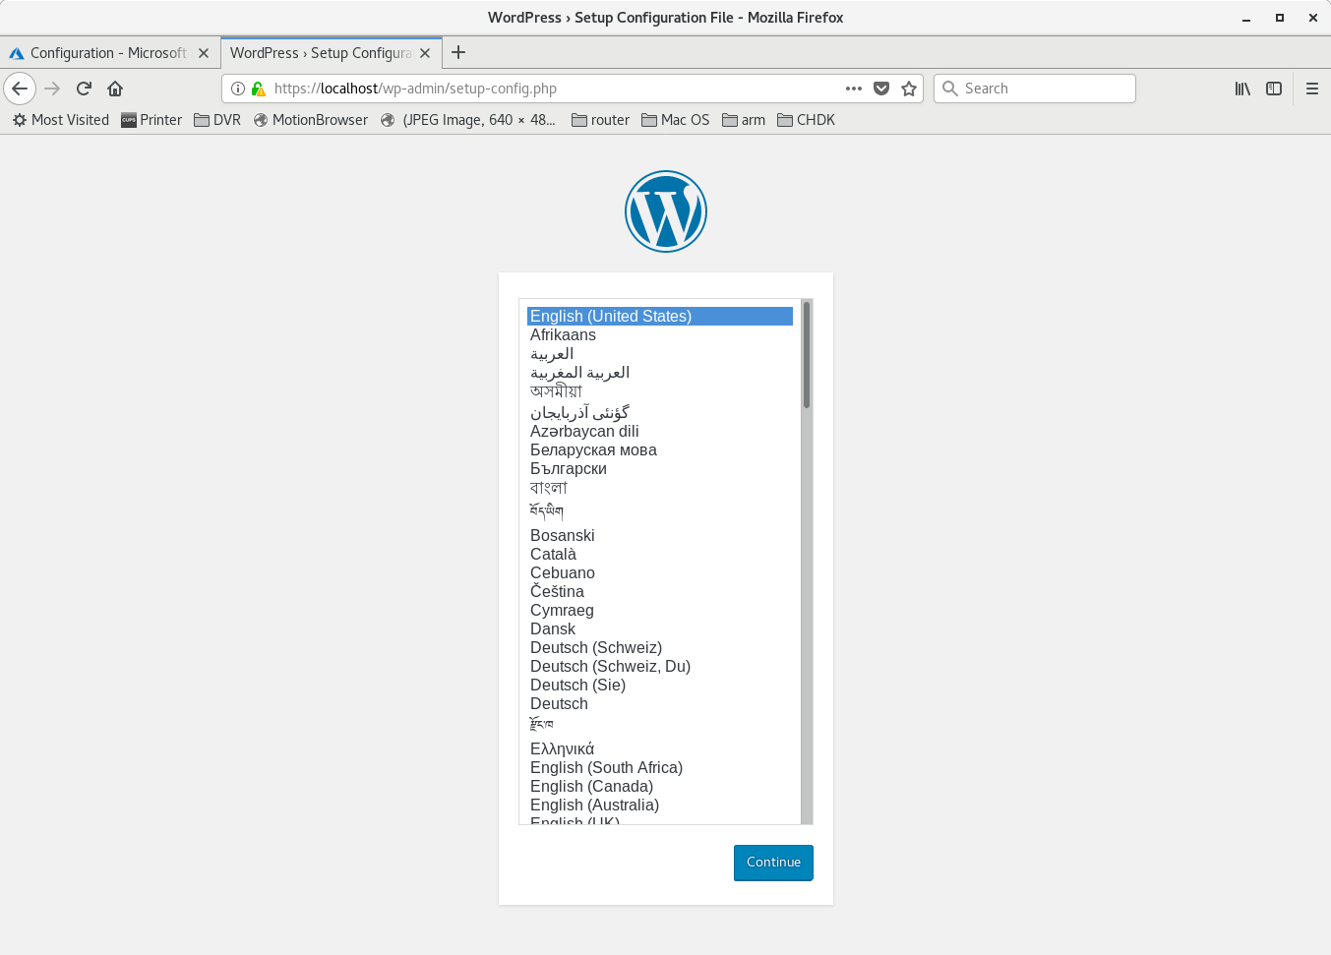

“English” should be highlighted.
Hit the “Continue” button.
On the next screen hit the “Let’s go” button.

Update the fields
Database Name: wp_myblog
Username: duval
Password: myblogdbpassword

Click the “Submit” button.

If everything is fine you’ll get a screen with the “Run the installation” button, which you want to click on. This brings you to a screen for configuring the wordpress administrator. Enter the fields

Site Title: The blogger’s place
Username: admin
For the password field use the password used to login to the VM
For email enter your email address

Then click on the “Install WordPress” button

The click the “Log In” button, and if all goes well you’ll be at this screen:

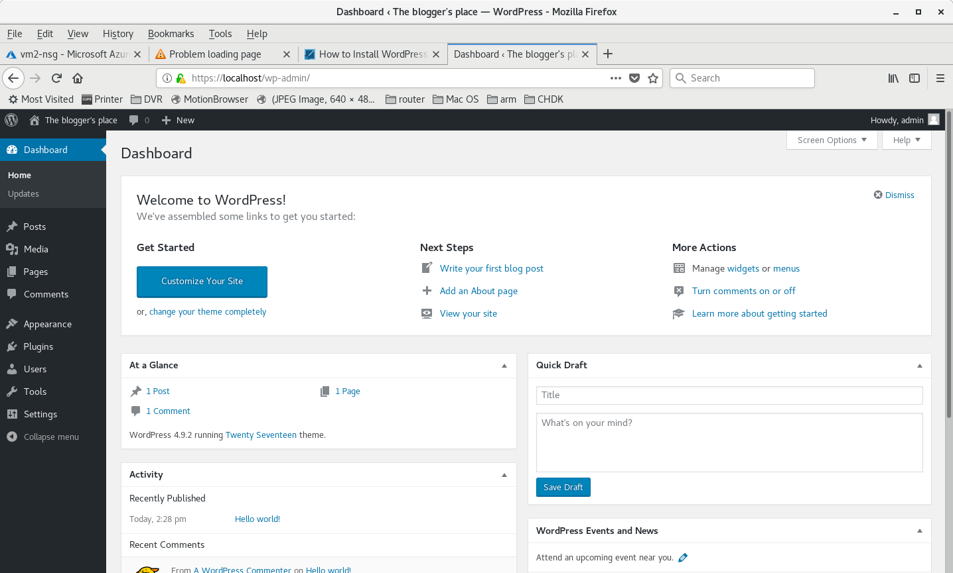

From the left hand menu, click on “Post”, there’s one existing post Hello World, If you mouse over “Hello world!” it’ll bring up a menu with an “Edit” option. Select the Edit option and change the post heading and then the content of the post. It doesn’t have to be anything special, just put a few sentences and then select the “Update” button that’s over to the right.

If you want to see your blog site like normal users, at the top there is a house button. When you mouse over the house it brings up the “Visit site” option, select it.

Look around then head back to the admin page by mousing over on the dial that replaced the house and select “Dashboard” from the menu that pops up.

From the menu on the left side of the screen mouse over Appearance and select “Themes”

Mouse over the “Twenty Sixteen” Theme and select the “Activate” button

Mouse over the “house” and select “Visit site” to see how the site changed

Mouse over the “dial” that replaced the house and select “Themes”

Mouse over the big plus sign in box “Add New Theme” and click on it

Click on “Popular” then scroll down and find “modernize” , mouse over it and select “Install”.
Once it installs the Install button will change to “Activate”, click on “Activate”

Mouse over the “house” and select “Visit site” to see the new theme

Mouse over the “dial” that replaced the house and select “Themes”

Mouse over the big plus sign in box “Add New Theme” and click on it

In search box type bluegray

Mouse over BlueGray theme and click on “Install” and then “Activate”

Mouse over the “house” and select “Visit site” to see the new theme

Mouse over the “dial” that replaced the house and select “Dashboard”

In the left hand menu mouse over “Setting” , then click Discussion and uncheck “Comment Author must fill out name and email”, “A comment is held for moderation” and “Comment author must have a previously approved comment”.
Scroll down and under Default Avatar select “Wavatar”
Scroll down and click on “Save Changes” at bottom of page.

Mouse over “Post” in left hand menu and click on “Add New”. Fill in title and add something in the post edit box. The click on the “Publish” button on the right.

Mouse over the “house” and select “Visit site” to see the new post.

Click on the “Read More” button just under your new post.
Add some text to the comment field and the “Post Comment”

Now log out of the admin user by mousing over “admin” in upper right hand side and selecting “Log out”

We want regular users to access the web site via port 80 (http) and the administration user to access the word press site via port 443 (https).
Make sure you can access the site on port 80 by surfing to http://localhost/
Attempt to connect to the wp-admin page on port 80 and make sure it redirects to port 443 by attempting to surf to http://localhost/wp-admin, which should redirect you to https for the login page.
Log back in.
Assuming this works , next change the URL in the wordpress configuration to be the correct external domain. Mouse over “Setting” and select “General”. Modify the “WordPress Address” and “Site Address” to be https://vmX-duval.eastus.cloudapp.azure.com where the X is the number you were given for your VM. Scroll down to the bottom and select “Save Changes”. At which point the site has to be accessed remotely so lets hope you got the domanin correct.

Tell your mentor you’re ready to expose your site to the internet so he can update the azure firewall.

Now in your web browser access your site URL at https://vmX-duval.eastus.cloudapp.azure.com

These lines in the appache ssl configuration file keeps people from access anything from this directory, unless they are accessing via localhost

<Directory "/var/www/html/wp-admin/">
Options Indexes FollowSymLinks MultiViews
AllowOverride All
Require local
Require ip 127.0.0.1
</Directory>

https://www.tecmint.com/install-wordpress-on-ubuntu-16-04-with-lamp/

