In this exercise we’ll be loading a ipfire firewall on an orange pi

Do do this exercise you need 7Zip, putty and Win32diskmanager on your PC. If they are not currently install on your laptop you can pull them from http://connectionblocks.com/tools/ and install them.

- We start by pulling the arm based version of ipfire from: https://www.ipfire.org/download/ipfire-2.21-core127
- Once downloaded, this file is in your download folder in compressed xz, right click on the file and select the option 7-Zip→Expand Here to decompress the file
- Put you micro sd into the laptop, if it pops up a screens to format the card, select “Cancle” then run win32Diskimager, select the SD and the uncompressed ipfire image and the “Write” button to write the image to the micro sd.
- When the write completes eject the micro sd drive from Windows and then insert it into your pi
- Connect your USB Network dongle into the individual vertical USB slot to the right of the NIC interface.
- Plug the outside interface network cable into the NIC directly on the pi
- Connect the usb console port from your pi to your laptop. I already have the pins connected to the pi. If they come off look at previous exercises to get the proper pin connections
- Use device manager in windows to determine the correct COMX port number as we need this for putty
- Start putty, check “Serial”, in the “Serial line” enter the COMX value you determined from the last step. For “Speed” enter 115200, then click the “Open” button. A blank putty window should pop up.
- Connect the power to your pi and you should see the console messages in the putty window indicating the device is booting.
- If all goes well with the ipfire installed image the first thing you should see is a screen like this asking about the keyboard type:
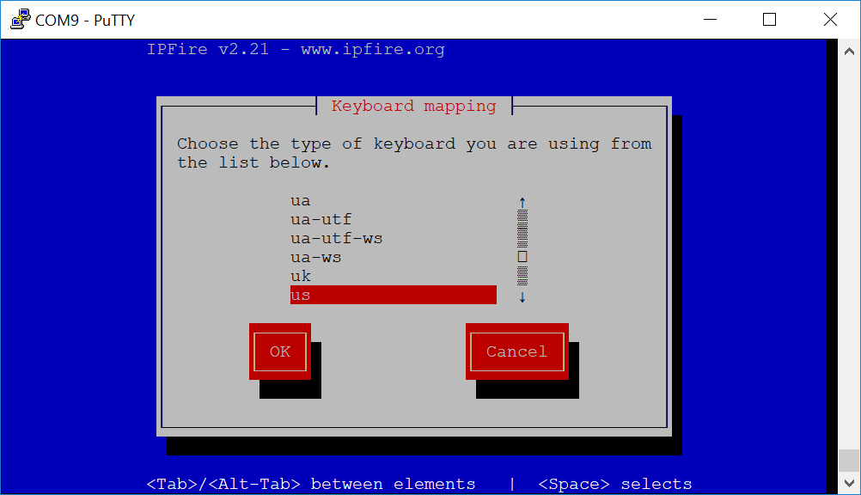
- As “us” is correct use the tab key to highlight OK and hit enter
- Next screen will ask about timezone, use the up key to highlight “US/Eastern” and hit the “enter” key.
- You’re asked to enter the machine’s name, “ipfire” is filled in, change this to “ipfire-YourInitials”. So something like ipfire-bkp and then hit the enter key
- He will ask for the domain name with a default of localdomain, just hit enter to accept.
- You are asked to enter the root password, enter ipfire , Note nothing will display as you type. Hit the tab key to go to the “Again” field and enter ipfire again, then hit the tab key to highlight “OK”. Finish that up by hitting the enter key.
- You are asked to enter the admin password for accessing the web interfase, enter ipfire , Note nothing will display as you type. Hit the tab key to go to the “Again” field and enter ipfire again, then hit the tab key to highlight “OK”. Finish that up by hitting the enter key.
- Next Is “Network configuration type”, tab to highligh ok, then select “GREEN + RED”, this says we are building a firewall with a LAN and a WAN segment. Tab to highlight “OK” and hit enter, it should return to the menu with “Network configuration type”
- Arrow down to “Drivers and card assignments” and hit enter
- Green should be highlighted, hit enter
- High light the USB device and hit enter
- Arrow down to highlight RED and then hit enter
- The on board device should be listed, on the orange pi this is dwmac-sun8i so just hit enter again
- Tab over to “Done” and hit enter
- Arrow down to “Address settings” and hit enter
- Green should be highlighted, so hit enter
- It’ll give a warning, just enter enter to select “OK”
- In the IP address field enter the 10.100.X.1, where X is replaced by the digit the mentor assigns you with Network mask of 255.255.255.0
- Arrow down to RED and hit enter
- Arrown down to DHCP, hit the space bar to move the ‘*’ then tab down to OK and hit enter
- Tab over to “Done” and hit enter
- We will not be setting DNS and Gateway as they will be assigned by DHCP we just set up on the red interface, so tab over to “Done” and hit enter
- You will be asked if you want to configure DHCP, this is for the Green/internal interface. Enable should be highlighed, hit the space bar to put an ‘*’ by enabled, then tab over to “Start Address” and enter 10.100.X.100, where X is replaced by the digit the mentor assigned you and then tab to the “End Address” and enter 10.100.X.120, then tab to “OK” and hit enter
- It should indicate Set up is complete and OK should be highlighted, hit enter
- At this point the system will start things up and you should have your firewall loaded

