Add DMZ to your firewall

In this exercise we’ll add a DMZ LAN segment with a web server on this LAN segment

- Connect the console USB converter to your laptop
- Use device manager on the laptop to figure out the correct COM port assigned to the converter
- Bring up putty and start a serial connection to this COMx port at a rate of 115200
- Connect an Ethernet cable from the network dongle on the IPFIRE PI to your laptop
- Connect an Ethernet cable from the IPFIRE on board network interface to the outside network
- Provide power to your IPFIRE and hopefully you’ll see the boot messages in the putty window
- Once booted login as root with the password we set in the last exercise: ipfire
- The date on your box is most likely going to be wrong, in the putty window run: date
  - This will display the date, if it’s incorrect by more than a few minutes DNS probably will not works. Try: nslookup google.com
  - If the IP address for google returns you’re fine so just jump to step 9, however if it didn’t work you need to set the date. You can do this with the date command. The date is provided in this format [MMDDhhmm[[CC]YY][.ss]]. March 9th 2019 4:25 PM would be set via: date 0309162519
  - Use the date command and try to set the date correctly on your IPFIRE PI, check the date you set using the date command with no parameter: date
  - If you think you set the date correctly then try: nslookup google.com
  - If you get a good response you can move on, else ask the mentor for help
- Plug the second dongle into the PI, The dongles need to be in the vertical USB port and the top of the two USB port of the two port stack
- Verify the system sees the second dongle via: lsusb | grep -v root
- If two devices are shown then you should be good, you can also do: ifconfig -a
- This should show red0, lo, green0 and a forth device, if you have for devices you can move on, else talk with the mentor
- In the putty window run: setup
  - Select Networking → Network configuration type
  - Highlight GREEN+RED+ORANGE then hit the enter key
  - Select Drivers and card assignments
  - Orange should show as “Unset”, GREEN and RED should have assignments
  - Highlight “OK” and hit enter
  - Highlight “ORANGE” and hit enter
  - One device should show and be highlighted, just hit enter
  - Highlight “Done” and hit enter
  - Highlight “Address Settings” and hit enter
  - Highlight “GREEN” and hit enter, we’re doing this to see what IP we have assigned to the GREEN LAN. It should be something like 10.100.10.1, Remember this as we’ll changing the second number from 100 to 200 for the ORANGE LAN segment.
  - Highlight “Cancel” and hit enter
  - Highlight “ORANGE” and hit enter
  - Fill in the ORANGE segment IP address, 10.200.X.1, where X matches the same value in the GREEN segment, then highlight OK and hit enter
  - Highlight “Done” and hit enter
  - Highlight “Done” and hit enter
  - It should indicate it’s “restarting network...”, it’ll take a while, when it returns, highlight “Quit” and hit enter
  - Run ifconfig to verify you now have the networks green0, orange0, red0 and lo
- In your laptop web browser connect to the IPFIRE via: https://IPFIRE_ADDR:444/ ,You need to replace IPFIRE_ADDR with the IP address of the IPFIRE green inteface
- Login as admin with the password we set, it should be ipfire
- To hopefully make our life easier lets enable SSH via the ipfire web interface
  - Select “System → SSH Access”
  - Check the “SSH Access” box
  - Check the “Allow TCP forward” so we can tunnel to the web interface
  - Uncheck “Set SSH port to default” , which movers SSH from port 22 to port 222
  - Click the “Save” button that’s too the right
  - In your console port putty window do: netstat -lntp
    - You should see something like
tcp 0 0 0.0.0.0:222 0.0.0.0:* LISTEN 1874/sshd
  - Bring up another putty window and see if you can ssh to the IP_ADDR on port 222
  - Login as root, the password should be ipfire
- Ask for your second PI, this PI is already loaded with the operating system
  - Connect and Ethernet cable from this new PI to the open IPFIRE USB network dongle
  - Plug this PI’s console to USB connector to your laptop
  - Use device manager to figure out the COM port assigned
  - Bring up putty and configure it for serial connection on this COMx port at 115200 data rate
  - Connect power to your PI. If all goes right you should see the console messages indicating it is booting. When you get to the login prompt login as user pi with password orangepi
- You may need to fix the IP address on your PI. Use “sudo ifconfig” to see the IP address assigned to your new DMZ PI. If it’s in the correct CIDR block for your ORANGE network then you’re good to go and can skip to step 19
  - To change the PI IP address use: sudo nano /etc/network/interfaces
  - Set the IP address and gateway to proper values for the ORANGE LAN and save the file
  - Restart the PI to reset the network: sudo shutdown -r now
  - After reboot, login as user pi password orangepi
  - Verify eth0 now has the correct address via: sudo ifconfig
- From the command prompt of the IPFIRE device see if you can ping the IP of the new DMZ PI, if not you need to debug this before moving on
- It seems the default policy for the DMZ (orange network) is to allow all traffic out through the firewall. We need to add appropriate rules through the IPFIRE web GUI to limit the traffic:
  - First rule uses Source → “Standard Networks” → ORANGE, Destination → Destination address of 8.8.8.8, Protocol → Preset → Services → DNS (UDP), Accept
  - Second rule uses Source → “Standard Networks” ORANGE, Destination → Stand Networks → RED, Protocol → Preset →ICMP, Accept
  - Third rule uses Source → “Standard Networks → ORANGE, Destination → Stand Networks → RED, Protocol → Preset → Services → NTP, Accept
  - Forth rule Source → “Standard Networks → ORANGE, Destination → Stand Networks → RED, Protocol → All, REJECT
  - These four rules need to be in the order I indicate they should be added, as firewall rules are evaluated from the top of the list down.
  - Click the check box to activate logging for the forth rule
  - Click the “Apply changes” button, and your rules should look something like this
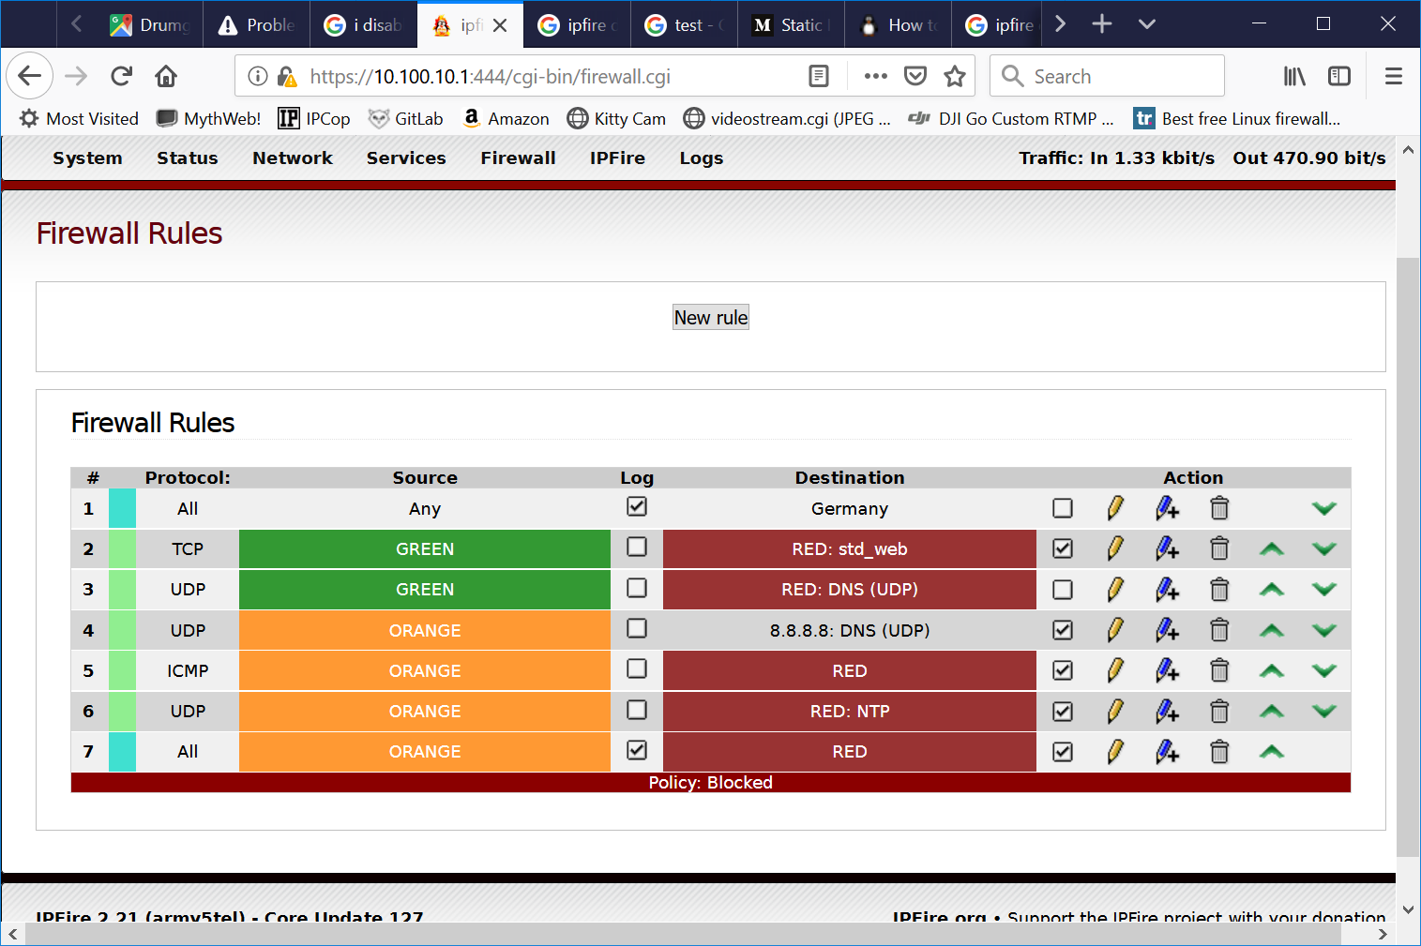
- You want to make sure your DMZ PI’s package list is updates so you can install a web server
  - Package updates happen on port 80, from the IPFIRE command prompt do the following: tail -f /var/log/messages | grep "SRC=10.200"
  - On the DMZ PI enter the command: sudo apt-get update
  - Your IPFIRE should display a number of log messages, which indicates the traffic is blocked.
  - Add a rule to allow outbound HTTP traffic from the DMZ: Source → Standard Networks → ORANGE, Destination → Stand Networks → RED, Protocol → Preset → Services → HTTP, Accept
  - You need to move this rule above the blue reject rule for the ORANGE network and click the “Apply changes” button
  - On the DMZ PI try the update again: sudo apt-get update
  - It should download most stuff but any connections via HTTPS will fail and at the end of the update it will tell you that port 443 connections failed.
- Installing the web server
  - On the DMZ PI’s command line install the apache web server: sudo apt-get install apache2
  - See if it’s listening on port 80: netstat -lnt
  - You should see that it’s listing for IPv6 (tcp6) but not IPv4 (tcp) on port 80, we want to shift this to use IPv4. At the command prompt:
sudo nano /etc/apache2/ports.conf
    - Change the line
Listen 80
to
Listen 0.0.0.0:80
    - Save the file
    - Restart apache: sudo service apache2 restart
    - Verify it’s now listen on port 80 tcp (IPv4) via : netstat -lnt
- Now on the Web interface for the IPFIRE device we need to add a port forwarding rule to route traffic over to the web server
  - Source → Standard Networks → Any, NAT → check “Use Network Address Translation” → Destination Nat → Firewall Interface → RED, Destination → Destination address → IP of your DMZ PI, Protocol → Preset → Services → HTTP, Accept
  - Add the rule and then “Apply changes”
  - From your laptop web browser if you surf to the outside interface of your IPFIRE firewall you should be redirected to the Apache default web page that looks like this:
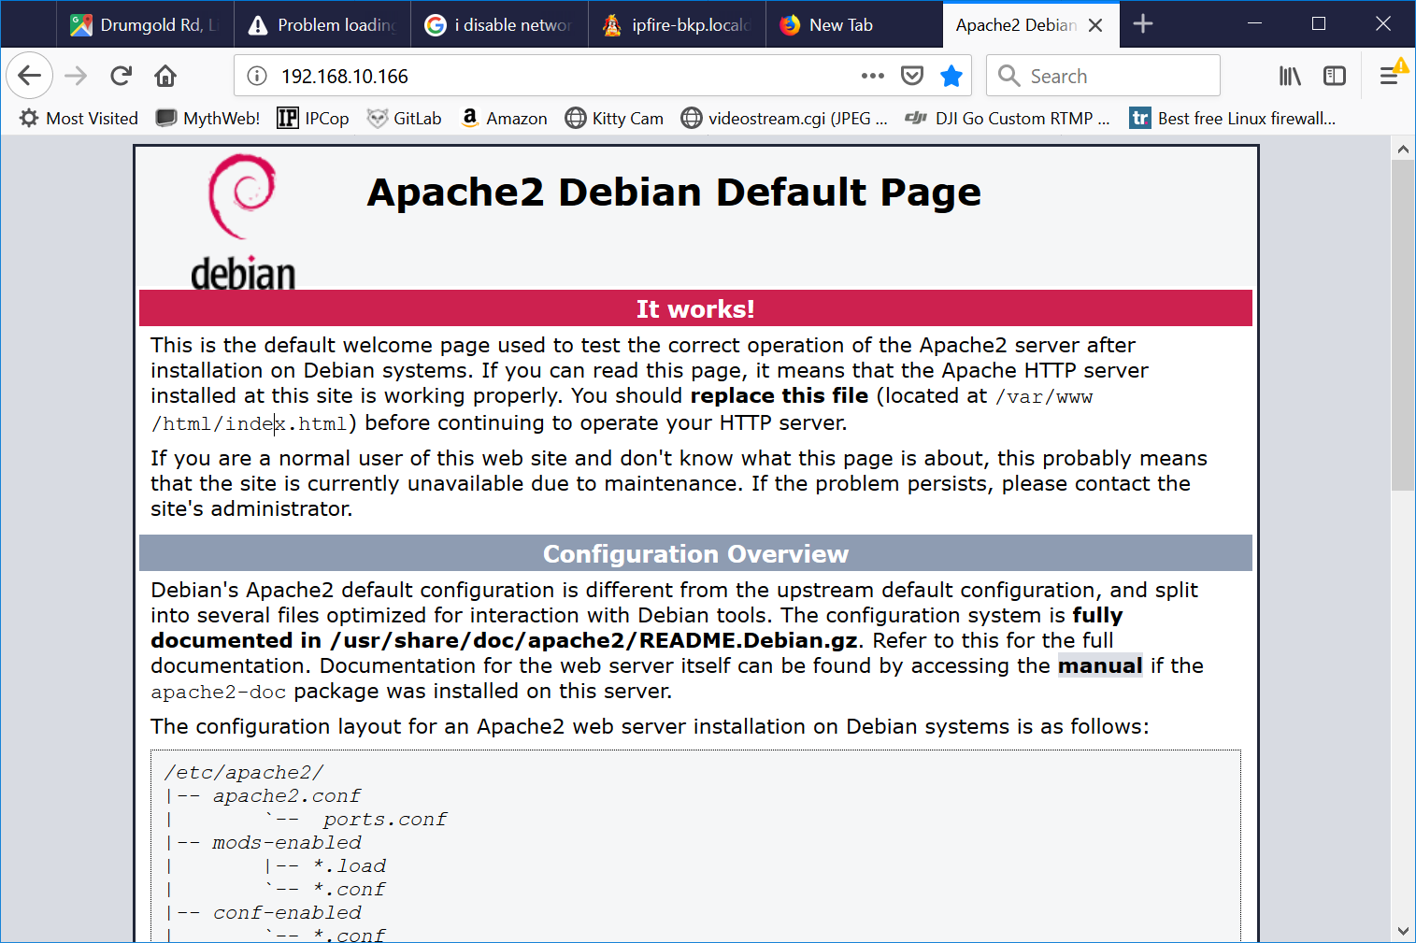
  - If that works, use the Mentors laptop which is attached to the outside network and verify that surfing to this same address gives the same result
- Cool, you now have a firewall that protects two LAN segments. One LAN segment for normal user traffic, and a second LAN segment for stuff you want to expose to the internet. If your internet exposed stuff is compromised the hacker does not have access to your other LAN segment, unless they can also hack your firewall.

Mentor’s notes for DMZ PI. Using armbian the following updates were made for each DMZ PI. The 3 octet of the CIRD block ranged from 1-X

systemctl stop NetworkManager.service
systemctl disable NetworkManager.service
vi /etc/network/interfaces
# The primary network interface
allow-hotplug eth0
iface eth0 inet static
address 10.200.1.2
netmask 255.255.255.0
gateway 10.200.1.1

vi /etc/resolv.conf
nameserver 8.8.8.8

update-rc.d networking enable
service networking restart

