Enable openVPN for remote clients on ipfire firewall

This exercise start with the assumption that the physical NIC is the external (red0) LAN segment, that there is a user LAN segment (green0) to which the laptop is connected and a DMZ (orange0) LAN to which a web server is connected.

- If it’s not already connected, then connect the serial to USB converter from your ipfire PI to your laptop
  - Use device manager on the laptop to identify the COM port assigned to the converter
  - Use putty and establish a serial connection to this COM port at a speed of 115200
  - Login as root with password ipfire
  - Use ifconfig to determine the ipaddress assigned to the green and red interfaces of your PI
- If the correct USB NIC on the ipfire is connected to your laptop, your laptop should have been assigned an IP from the ipfire in the CIDR block range of the green LAN segment
  - On the laptop start a cmd prompt and verify your ethernet device is assigned an appropriate IP addresses, if it isn’t talk with the mentor
- Access the IPFIRE web interface at https://IP_address_green0:444 - NOTE IP_address_green0 is something like 10.100.x.1, where X is the number you found in major step 1 above.
- The PI is a little slow building entropy, so when we do the next steps the Web interface will time out before all the crypo variables can be generated. We can speed things up by adding “-dsaparam” to the script that generates the cryto variables, specifically the diffie-helman variables. So that’s what we’re going to do now
  - download the file ovpnmain.cgi from http://www.connectionblocks.com/orange-pi/ to your laptop. You need to right click on the file name and select “save link as”, assuming you’re using firefox.
  - Use winscp to move this file over to your ipfire box, you’ll be logging as root
  - From the ipfire command prompt use the “ls” command to verify the file is on the ipfire PI
    - Assuming the file is on the ipfire box move it to the correct location vi:
mv ovpnmain.cgi /srv/web/ipfire/cgi-bin/ovpnmain.cgi
- In the IPFIRE web interface select “Services → OpenVPN”
  - Check “OpenVPN on Red” , in the “Local VPN Hostname/ip field enter the IP address assigned to your red0 interface and then click the Save button
  - We need to generate the encryption variables
    - Click on “Generate root/host certificates” button
    - Fill in Organization Name: DuVal CyberPatriot, Sate: MD, Country: US, Diffie-Hellman: 2048
    - Click the “Generate root/host certificates” button
    - It’ll take a couple minutes but should return with a screen like the one below, notice under the Certificate Authorities and keys all the values have been generated
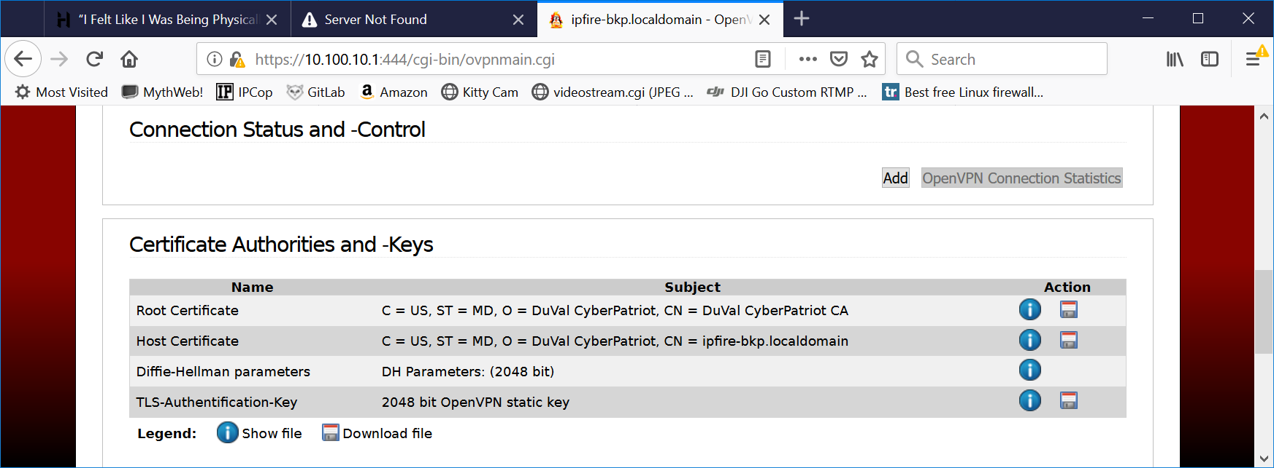

- Next we want to generate configuration for the remote user, click the “Add” button under “Connection Status and Control”
  - Make sure “Host-to-Net is select and then click the “Add” button
  - Fill in Name: user1 , Remark: Remote User1
  - Scroll down and make sure “Generate a certificate” is selected and fill in
    - User’s Full name: Remote user
    - Organization Name: DuVal CyberPatriot
    - State: MD
    - Country: United States
    - Valid till: 730
  - Under “Advanced client options”
    - Make sure both ORANGE and GREEN are both highlighted
  - Click “Save”
- Start openVPN by clicking the “Start OpenVPN Server” button
- Under “Connection Status and Control” you should see user1, to the right of this it indicates DISCONNECTED, the square icon next to this allows you to download a ZIP with the openVPN configuration information that will enables the laptop to connect to the ipfire device from outside the firewall. Download this zip file. We will import this file into the openVPN application once we’ve installed it below. You need to expand the zip file to access the files.
- Before we move any cables we want to set up a rule that gives the openVPN application access to the ipfire GUI. So from the ipfire web interface “Firewall → Firewall Rules”
  - Click the “New rule” button and enter the following rule
  - Source → Standard Networks → OpenVPN, Destination → Firewall → Green, Protocol → All Accept, Additional Setting → Rule Position → 1, then click “Add”
  - Click “Apply changes”
- On the laptop we need to install the openVPN application if it isn’t already installed on your laptop. You get it from here:
http://connectionblocks.com/tools/openvpn-install-2.4.6-I602.exe
- Run this file to install the openVPN application
- Now run the openVPN application, it should place a icon on the right side of the task bar
  - right click on the openVPN icon, then select “Import file…”, you want to select the user1-TO-IPFire.opvn file.
  - We need to also put the user1.p12 file that was also in the zip file in the right place on your laptop. Copy or move this file to c:\Users\YOUR_LOGIN_DIRECTORY\OpenVPN\config\user1-TO-IPFire directory.
- Now you need to move your laptop to outside the firewall by connecting the laptop wired NIC to the same LAN segment your red0 interface is connected to. Verify a new IP address is assigned to your laptop ethernet device using ipconfig. This IP should be in the same CIDR block as the red0 interface on your ipfire device.
- You can now attempt to connect to your firewall via
  - right click the OpenVPN client icon in the taskbar again and click Connect.
  - The OpenVPN client will pop up a window and print log message as it attempts to connect to your ipfire Pi’s VPN server. If it connects this window will go away. If the OpenVPN icon in the task bar turns to a solid green, then it means that you have successfully connected into your VPN. However, if it turns yellow and fails to turn green after 60 seconds that means something is causing the connection to fail, so talk with the mentor about the issue.
  - See if you can now connect to the ipfire web interface, using the IP address of the green0 interface and port 444.
- If you still have time create a rule that gives the openVPN user access to the ssh port of the Web server behind your firewall.

